Questions

Please refer to the .csv files shared on the Gdrive and complete the below.

1. lda_gaussian.csv
The objective here is to understand when LDA works well
Tasks:
- Apply Linear Discriminant Analysis (LDA)
- Project data to 1D
- Plot histogram of projected values
Questions:
- Do the two classes separate clearly after projection?
Answer – yes the two classes separate clearly
- What property of the dataset helps LDA perform well?
Answer – The difference in class which helps clear projection after applying LDA
- How are class means positioned in the projected space?
Answer – Means are far apart and have different values
- Would Principal Component Analysis (PCA) also perform well here? Why or why not?
Answer – Yes PCA also perform well with this data

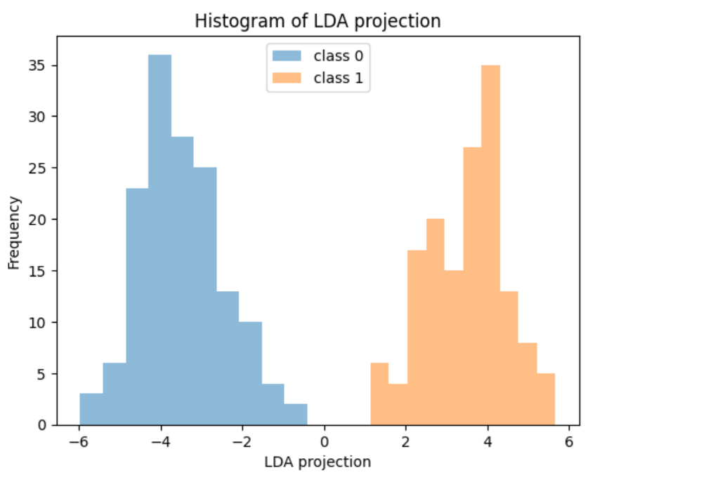
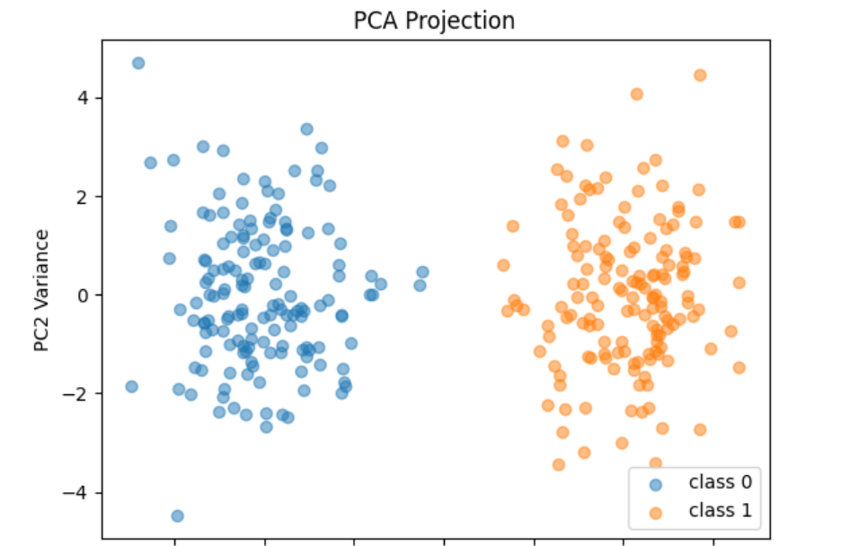

2. lda_nongaussian.csv
The objective here is to understand LDA limitations
Tasks:
- Apply LDA
- Visualize projection (1D or 2D)
Questions:
- Is class separation as clear as in the Gaussian dataset?
Answer – No, the two classes were not separated clearly
- What assumption of LDA is violated here?
Answer – Normal distribution
- How does the shape of the data affect LDA performance?
Answer – Separation not clear
- Would PCA perform better or worse here? Explain.
Answer – PCA works betters with better separation

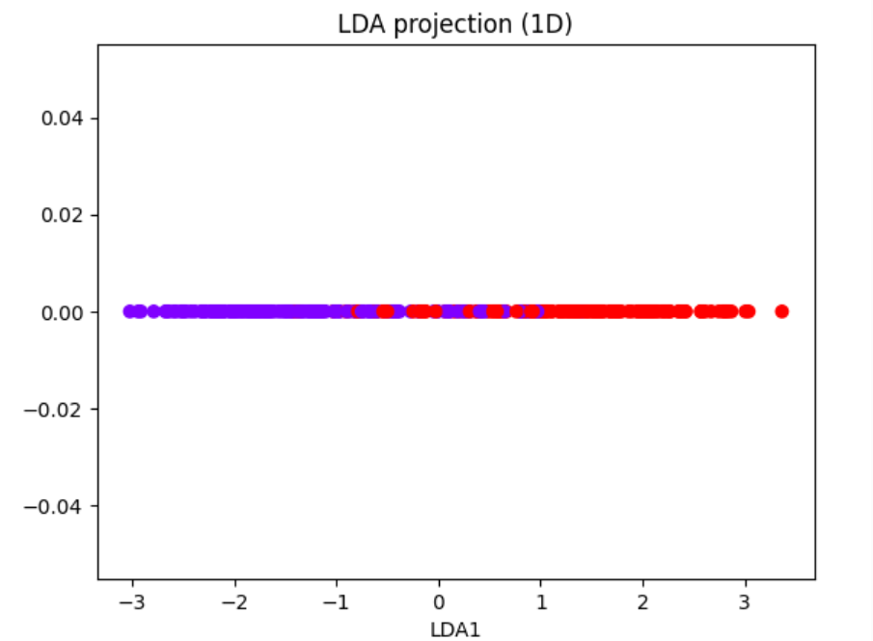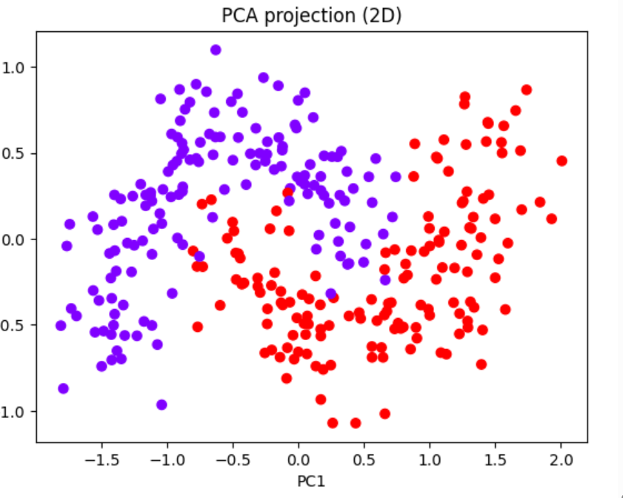

3. lda_unequal_covariance.csv
The objective here is to study covariance effect
Tasks:
- Apply LDA
- Plot transformed data
Questions:
- Do classes overlap after LDA projection?
Answer – yes, classes overlap
- What does this tell you about covariance assumptions?
Answer – LDA does not work well with high covariance
- How are the spreads of the two classes different?
Answer - The two classes likely have different shapes or orientations.
- Why does LDA struggle when covariance differs?
Answer – LDA work when the covariance is same however if it varies it does not accurately represent the class separation

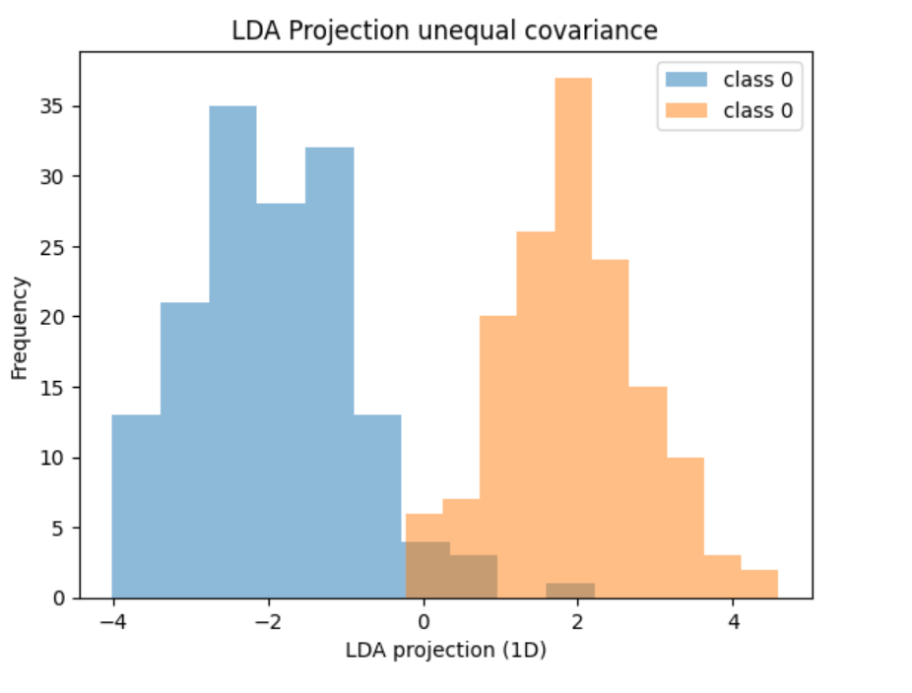

4. lda_multiclass.csv
The objective here is to understand component limitation
Tasks:
- Apply LDA
- Check number of components returned
- Try projecting to 2D and 3D
Questions:
- What is the maximum number of LDA components obtained?
Answer – 3
- Verify the formula:
components ≤ (number of classes − 1)
Answer – 4 classes reduced to 3, the formula holds correct
- why can’t LDA produce more components?
Answer - LDA is based on between-class scatter and within-class scatter matrices. If there are 4 groups max it can separate till 3, 4th would not create any distinction
- What happens to information beyond these components?
Answer - LDA is used only for classification tasks and not for dimensionality reduction

5. lda_clean.csv vs lda_noisy.csv
The objective here is to study noise sensitivity
Tasks:
- Apply LDA on both datasets
- Compare projections
Questions:
- Which dataset shows clearer separation?
The clean dataset will show clusters that are more distinct and separated along LD1 and LD2.
The noisy dataset will show overlapping clusters, making class boundaries less clear.
- How does noise affect LDA performance?
Noise introduces irrelevant variance that does not contribute to class separation.
LDA tries to maximize between-class variance, but noise inflates within-class variance, reducing discriminative power.
Result: poorer separation, lower classification accuracy.

- Do irrelevant features influence LDA direction?
Yes. LDA computes scatter matrices using all features.
- What does this imply for real-world data?
Feature selection or pre-processing (e.g., removing noisy variables, normalizing data) is crucial before applying LDA.

6. lda_imbalanced.csv
The objective here is to understand class imbalance
Tasks:
- Apply LDA
- Visualize projection
Questions:
- Is one class dominating the projection? - YES
- How does imbalance affect class means? – ONE CLASS HAS MORE DATA POINTS AND IS RELIABLE
- Does LDA treat both classes equally? - YES
- What risks does imbalance introduce? – POOR SEPARATION AND BIASED CLASSIFICATION

7. lda_feature_importance.csv
The objective here is to interpret LDA coefficients
Tasks:
- Fit LDA
- Extract coefficients (lda.coef_) # print(lda.coef_) you would get the coefficients
- Rank features
Questions:
- Which features are most important for separation? FEATURES WITH LARGE COEFFICIENTS LIKE F5, F2
- Are some features negligible? YES F3 AND F1
- How do coefficients relate to class separation? THEY DEFINE THE AXIS ALONG WHICH MEAN ARE MAXIMALLY SEPARATED
- Can LDA be used for feature selection? Why? INDIRECTLY YES, LDA IS NOT A FEATURE SELECTION ALGORITHM, ITS COEFFICIENTS REVEAL FEATURE RELEVANCE

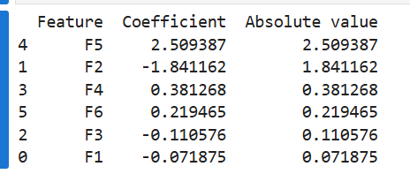

8. lda_failure_nonlinear.csv
Objective: Identify failure case
Tasks:
- Apply LDA
- Visualize projection
Questions:
- Does LDA separate the classes effectively? NO, IT OVERLAPS
- What is the shape of the data distribution? NON LINEAR AND OVERLAPPING
- Why does LDA fail in this case? LDA WILL WORK ONLY IF THE CLASSES ARE LINEARLY SEPARABLE
- What type of boundary would be required instead? KERNEL LDA

LDA MCQ Set

Q1. What is the main objective of LDA?
A. Maximize total variance
B. Minimize reconstruction error
C. Maximize class separability
D. Reduce feature correlation

Q2. LDA is a:
A. Unsupervised method
B. Supervised method
C. Reinforcement learning method
D. Clustering technique

Q3. LDA requires which of the following?
A. Only features
B. Only labels
C. Features and class labels
D. Neither features nor labels

Q4. What does LDA try to maximize?
A. Within-class variance
B. Between-class variance
C. Ratio of between-class to within-class variance
D. Total variance

Q5. Key difference between LDA and Principal Component Analysis (PCA)?
A. LDA is unsupervised, PCA is supervised
B. PCA uses labels, LDA does not
C. LDA uses labels, PCA does not
D. Both are identical

Q6. Which method is better for classification tasks?
A. PCA
B. LDA
C. Both always equal
D. Neither

Q7. PCA may fail to separate classes because:
A. It ignores variance
B. It ignores class labels
C. It cannot reduce dimensions
D. It only works on binary data

Q8. Maximum number of LDA components is:
A. Number of features
B. Number of samples
C. Number of classes − 1
D. Number of classes

Q9. If you have 5 classes, maximum LDA components = ?
A. 3
B. 4
C. 5
D. 6

Q10. Within-class scatter matrix represents:
A. Distance between class means
B. Spread within each class
C. Total variance
D. Noise only

Q11. Between-class scatter matrix represents:
A. Spread within classes
B. Distance between class means
C. Feature correlation
D. Random noise

Q12. LDA assumes data is:
A. Uniformly distributed
B. Gaussian distributed
C. Exponential distributed
D. Random

Q13. LDA assumes:
A. Equal covariance across classes
B. Different covariance across classes
C. No covariance
D. Only diagonal covariance

Q14. LDA will struggle when:
A. Classes are well separated
B. Data is linearly separable
C. Classes have different covariance
D. Labels are available

Q15. LDA works best when:
A. Labels are not available
B. Classes overlap heavily
C. Classes are well separated
D. Data is random

Q16. LDA projection results in:
A. Non-linear boundary
B. Linear boundary
C. No boundary
D. Random mapping

Q17. In binary classification, LDA reduces data to:
A. 2 dimensions
B. 3 dimensions
C. 1 dimension
D. Depends on features

Q18. If class labels are randomly shuffled, LDA will:
A. Improve performance
B. Still work well
C. Fail to find meaningful separation
D. Become PCA

Q19. Adding irrelevant features will:
A. Always improve LDA
B. Have no effect
C. Potentially degrade performance
D. Make LDA unsupervised

Q20. LDA can be used for:
A. Only classification
B. Only dimensionality reduction
C. Both dimensionality reduction and classification
D. Only clustering

